Database Encryption
NPM Package for Encryption: Mongoose Encryption (https://www.npmjs.com/package/mongoose-encryption )
Encryption: AES-256-CBC (strongest encryption standard)
Authentication: HMAC-SHA-512

Plugins
Schemas are pluggable, that is, they allow for applying pre-packaged capabilities to extend their functionality.
Plugins are extra bits of package code that we can add to mongoose schemas to extend their functionality. The core purpose of plugins is to manipulate your schemas. Plugins don't touch models or documents, so they can't execute queries or write to the database directly.

- Install Mongoose Encryption
$ npm i mongoose-encryption
- Create your encryption “secret” key for your encrypt plugin
// Encryption
const secret = "thisisourlittlesecret";

// Encrypt ONLY certain field/s using the encryptedFields option
userSchema.plugin(encrypt, {secret:secret, encryptedFields:["password"]});

Authentication Code Example:
- // Creating a schema for the database
- const userSchema = new mongoose.Schema({
- email: String,
- password: String,
- });

- // Encryption
- // You have to create a variable containing of any string and that variable should be put against secret: as JS object.
- const secret = "thisisourlittlesecret";
- // Encrypt ONLY certain field/s using the encryptedFields option
- userSchema.plugin(encrypt, {secret:secret, encryptedFields:["password"]});

- app.post("/register", (req, res)=>{
- const newUser = new User({
- email: req.body.username,
- password: req.body.password
- });
- newUser.save((err)=>{
- if (!err) {
- console.log("[INF][POST][/REGISTER] OK!");
- res.render("secrets");
- }
- });
- });

- app.post("/login", (req, res)=>{
- const username = req.body.username;
- const password = req.body.password;

- User.findOne({email: username}, (err, foundUser)=>{
- if(foundUser) {
- if (password === foundUser.password) {
- console.log("[INF][POST][/LOGIN] OK!");
- res.render("secrets");
- } else {
- console.log("[ERR][POST][/LOGIN] USERNAME AND PASSWORD INCORRECT.");
- res.render("login");
- }
- } else {
- console.log("[ERR][POST][/LOGIN] ERROR IN RETREIVING USER ", err);
- res.render("login");
- }
- })
- });
The way that Mongoose Encrypt works is that it will encrypt when you call save and it will decrypt when you call find.
When you create a new user with an email and password and call save (Line 18), automatically behind the scenes, Mongoose Encrypt will encrypt your password field (since it’s specified in the encryptedFields option that you want to only encrypt the password field).
And when later on you will call find (Line 30) the document based off the e-mail entered, Mongoose Decrypt will decrypt the password field to be able to check if the passwords matched and see if the user can login.

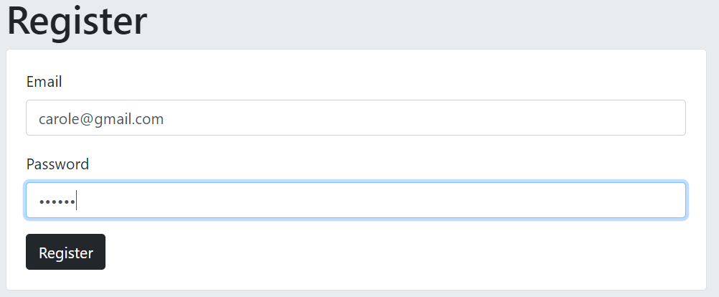
Email: carole@gmail.com
Password: qwerty
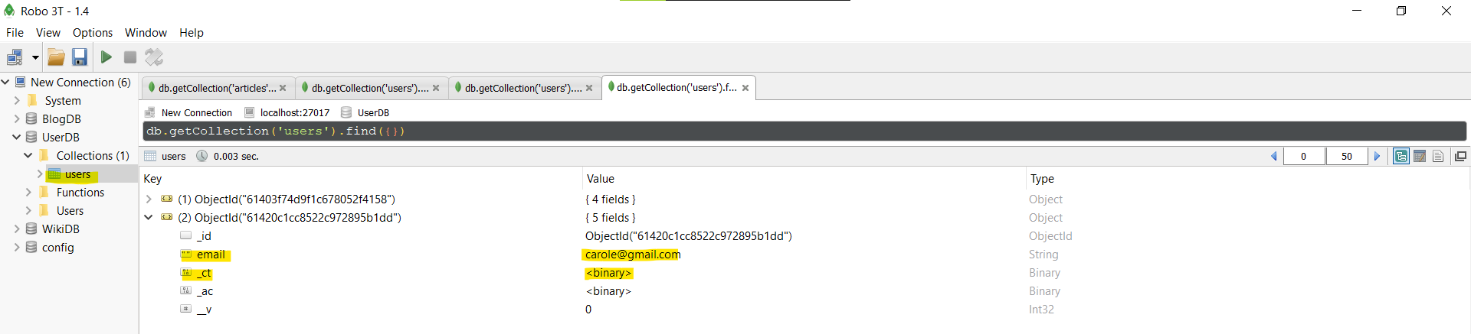
Right click on _ct > View Document
With the encryption, your user’s password is now in a very long binary encrypted string that’s very hard to guess.
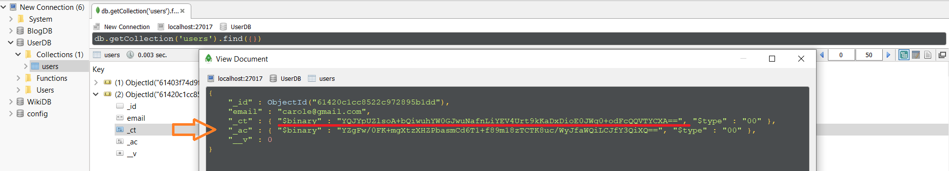

What is the use of the “secret” variable?
Encryption and Decryption is going to always need a "key".
Going back to the Caesar Cipher, one needs to agree on how many spaces to shift. So, Caesar and his generals (on the intended receiving end) would have to know this beforehand. They would agree on for example, shift by 4. So Caesar would shift by 4 and send his messages. His generals on the receiving will un-shift by 4 and decrypt the message.
[shift: 4]
In our case here, the long text variable called "secret" has the value of "thisisourlittlesecret" (or whatever you string you chose to declare). This is the actual key for the encryption we are using here - AES 256 with CBC.
[secret: thisisourlittlesecret]
This is passed as one of the parameters below:
userSchema.plugin(encrypt, {secret: secret, encryptedFields: ["password"]});
Basically this is our way of telling the encrypter – AES 256 with CBC – to keep the spacing as "4" or in other words worth “thisisourlittlesecret” shift.
If you changed your secret key (let’s say to: “ihatesecrets”) after adding some documents using the thisisourlittlesecret secret key, an authentication error will occur when your app will try to decrypt a document that was encrypted using the thisisourlittlesecret key.
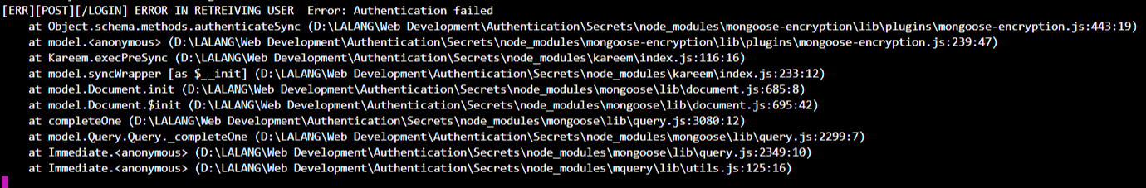

Environment Variables
When you upload your files to GitHub, you files (particularly app.js) may have sensitive data that shouldn’t be accessed by the public.
This is where environment variables come to the picture. It is a simple file that’ll keep certain sensitive variables such as encryption keys and API keys.
NPM Package: DotEnv https://www.npmjs.com/package/dotenv

Installing NPM Package: DotEnv
$ npm i dotenv

- Require DotEnv as soon as possible in your application
require('dotenv').config()
No need to declare a constant.
We just need to require it and call config() and we don't need it again since it will be active and running.
It must be placed at the top most part of your application. If not, your environment variable will not be accessible it if it is not configured.

- Declare an Environment Variable in the .env File
Create a “.env” file in your application’s root directory.
Add environment-specific variables in the .env file in the form of NAME=VALUE
No spaces, no quotation marks
NAME should ideally be in capitalized snake case (words separated by an underscore).

the secret key:
const secret = “thisisourlittlesecret”;
transferred to .env file (in the correct format):
SECRET=thisisourlittlesecret

Note: Make sure you add .env file in .gitignore

- Access the Environment Variable from app.js
Syntax:
variable_name = process.env.<NAME>

Example:
const secret = process.env.SECRET;

Now, when commiting file to GitHub, your confidential keys will not be accessible

